BIOS Tool User Guide

v0.2

Jerry Chen

February 2018

# Revisions

|  |  |  |
| --- | --- | --- |
| Revision | Date | Description |
| 0.2 | February 2018 | 1. Setup parsing function: Produce setup item’s information in excel file |
| 0.1 | October 2017 | Initial release |

THIS WHITE PAPER IS FOR INFORMATIONAL PURPOSES ONLY, AND MAY CONTAIN TYPOGRAPHICAL ERRORS AND TECHNICAL INACCURACIES. THE CONTENT IS PROVIDED AS IS, WITHOUT EXPRESS OR IMPLIED WARRANTIES OF ANY KIND.

Copyright © 2017 Dell Inc. All rights reserved. Dell and the Dell logo are trademarks of Dell Inc. in the United States and/or other jurisdictions. All other marks and names mentioned herein may be trademarks of their respective companies.

Table of contents

Revisions 2

Executive summary 4

1 Document control information 5

1.1 References and definitions 5

2 BIOS POST log parsing tool 6

2.1 Transfer Guid to meaningful name 6

2.2 Produce EFI driver initial sequency 7

2.3 Example 7

3 Setup parsing function (Only for Dell AMI code) 8

3.1 Produce setup item’s information in excel file 8

3.2 Example 9

3.3 Know issue 10

# Executive summary

This tool offers 3 functions for BIOS engineers to trace BIOS information.

1. BIOS POST log parsing tool: Transfer Guid to meaningful name

2. BIOS POST log parsing tool: Produce EFI driver initial sequency

3. Setup parsing function: Produce setup item’s information in excel file.

# Document control information

## References and definitions

1. References

| Document Title | Source |
| --- | --- |
|  |  |

1. Definitions and abbreviations

| Term | Definition |
| --- | --- |
| DPF | Dell Provided Features: UEFI drivers developed by Dell |
| UEFI | Unified Extensible Firmware Interface: specification that defines as software interface between an operating system and firmware |
| GUID | Globally Unique Identifier: 128-bit integer number used to uniquely identify computing resources |
| PID | Property Identifier: identifier for platform specific variables used to customize BIOS behavior for any given Dell platform |

1. Reference Platform

| Chipset | Dell Platform |
| --- | --- |
| Sky Lake | Magellan2 |
| Kaby Lake | LivingStone2, Swordfish |
| Baytrail | St.louis, Caracella |

# BIOS POST log parsing tool

Machine generated alternative text:
BIOS Logfile Analysis Gset Analysis 
project Location: project root path 
POST LogFile: 
LivingStone2.10g 
Refresh Guid Temolate 
Reolace LooFile Guid 
Produce Driver Loadina Seauence 

## Transfer Guid to meaningful name

Step 1. Press icon 1 to choose your project source code folder

Step 2. Press icon 2 to choose your project’s POST log file.

Step 3. Option. You can press icon 3 to reflash Guid Template

Step 4. Press icon 4 to produce new Post log file with meaningful name

Status will show on icon 6

## Produce EFI driver initial sequency

Step 1. Press icon 1 to choose your project source code folder

Step 2. Press icon 2 to choose your project’s POST log file.

Step 3. Option. You can press icon 3 to reflash Guid Template

Step 4. Press icon 5 to produce drivers loading sequency

Status will show on icon 6

## Example

Project: Livingstone2

Post log file: c:\putty.txt

**[Transfer Guid to meaningful name]**

1. Press icon 1 to choose C:\BIOS\Rugged2\Liv2_99.0.41_Rev0901_BT
2. Press icon 2 to choose c:\putty.txt
3. Press icon 3
4. Press icon 4. Check icon 6 message

**[Produce EFI driver initial sequency]**

1. Press icon 1 to choose C:\BIOS\Rugged2\Liv2_99.0.41_Rev0901_BT
2. Press icon 2 to choose c:\putty.txt
3. Press icon 3
4. Press icon 5. Check icon 6 message

# Setup parsing function (Only for Dell AMI code)

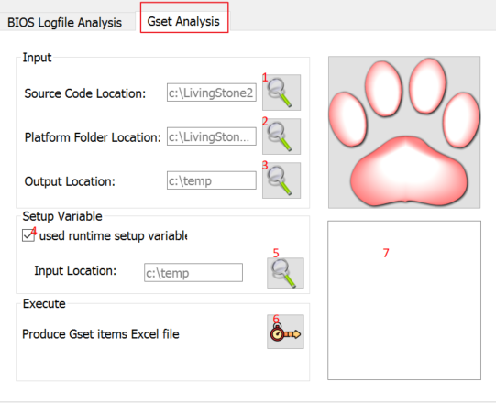

## Produce setup item’s information in excel file

**[Prepare data before running this function]**

1. Prepare your target project bios source and already running local build. Build folder must exist because this tool need some files under this folder.
2. (Option) Power on machine and boot to EFI shell.

Run these command to gather runtime variable.

Dmpstore Setup –s Setup.bin

Dmpstore BootManager –s BootManager.bin

Dmpstore SetupAmtFeatures –s SetupAmtFeatures.bin (Bay trail don’t need this, they don’t use AMT)

Put these files on your’s PC folder. Later tool will use it.

**[Start to run the function]**

Step 1. Press icon 1 to choose your project source code folder

Step 2. Press icon 2 to choose your project’s OEM folder.

Step 3. Press icon 3 to choose output files folder.

Step 4. Make icon 4 check status is enabled

(When it’s disabled. This tool will use default setup variable to produce setup items excel file

Some items won’t be the same as you see when you entering setup screen)

Step 5. Press icon 5 to choose the folder that include Setup.bin/BootManager.bin/SetupAmtFeatures.bin

Step 6. Press icon 6. When it will produce the setup item excel file

icon 7 will show the running message

Step 7. On output folder you will 2 new folders

Media folder: Files that produced by the tool are used for debug.

Release folder: Da_Token_Setup.xls

## Example

Project: Livingstone2

1. Press icon 1 to choose C:\BIOS\Rugged2\Liv2_99.0.41_Rev0901_BT
2. Press icon 2 to choose C:\BIOS\Rugged2\Liv2_99.0.41_Rev0901_BT\OEMBOARD\LivingStone2
3. Press icon 3 to choose C:\Output
4. Make sure icon 4 is enabled
5. Press icon 5 to choose C:\Input
6. Press icon 6
7. Go to C:\output, you will see Da_Token_Setup.xls

## Know issue

1. Precision projects (Matira3) run the tool will fail if icon 4 is unchecked.

Because there is no Defaults.bin under Build folder

1. On Excel file , you will see 2 strange strings.

Because these strings are updated during runtime. Current we don’t support the runtime message.

|  |  |
| --- | --- |
| Power Management |  |
|  | ERROR |

Root cause: #string STR_DELL_AC_BEHAVIOR_NULL #language eng "ERROR"

|  |  |
| --- | --- |
| Power Management |  |
|  | Error! String not set. |

Root Cause: #string STR_DELL_WOL_PLACEHOLDER #language eng "Error! String not set."